* Task get a swagger file of apigateway using boto3

Step 1: Create a API Gateway in AWS.

🡺 Search the API Gateway and click on that one

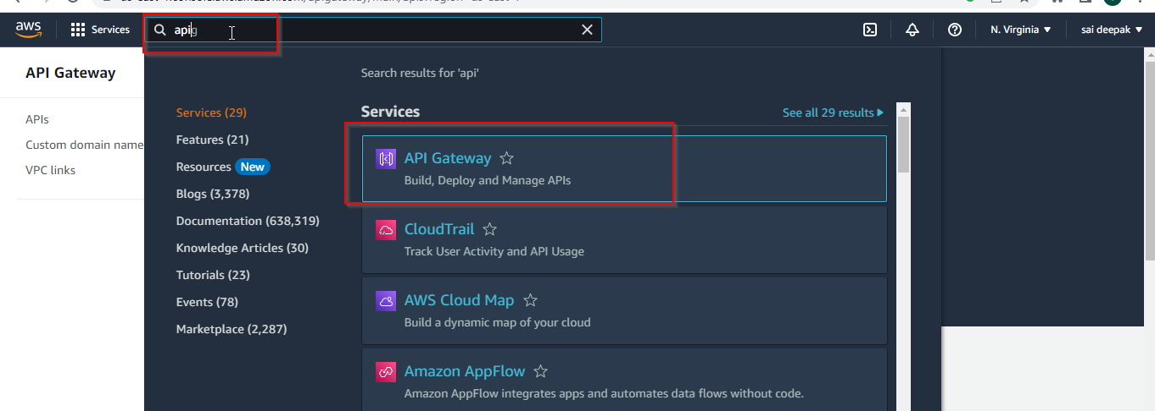

🡺 Click on the REST API and click on build Build

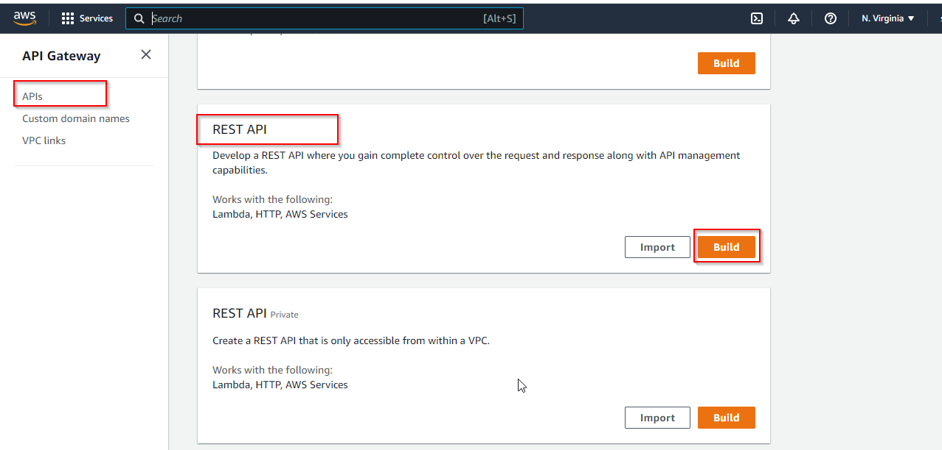

🡺 After Clicking the below page will appear

🡺 In This page we need to select the REST Protocol

🡺Create new API gateway Here I am selecting the Example API

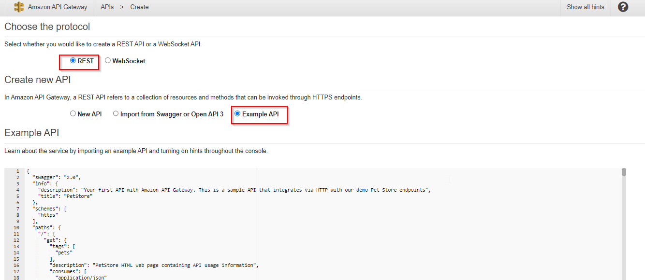

🡺 After Scroll down

🡺 Select the Scroll down click on Import

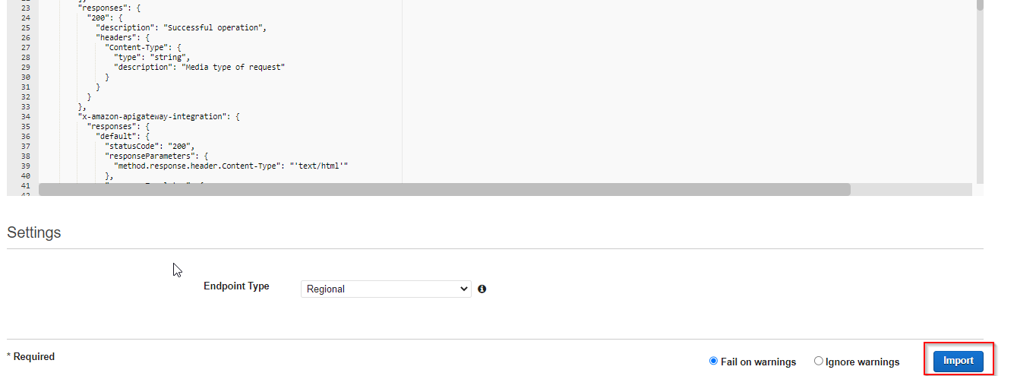

After Click on Import the below page will appear.

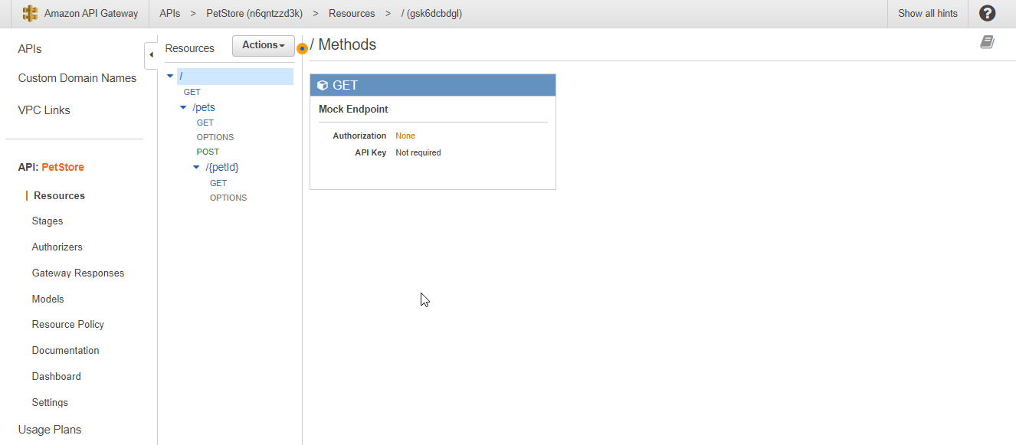

🡺After that need to click on that Deploy API

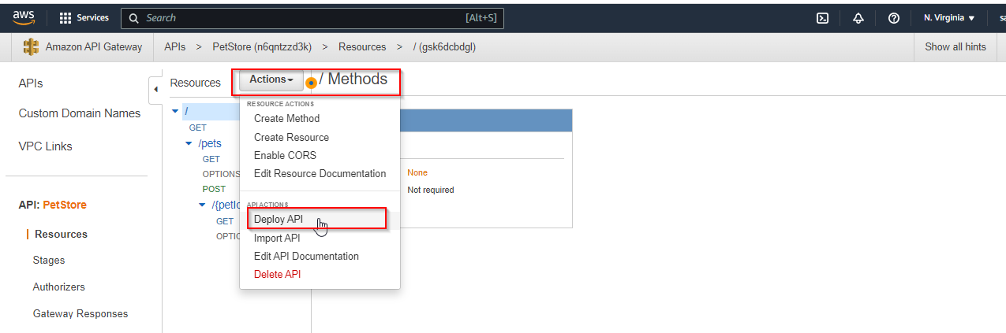

🡺After that Need to Enter Select the Deployment stage

🡺 need to enter the stage Name🡺 here I entered the Prod

🡺 After that click on the Deploy

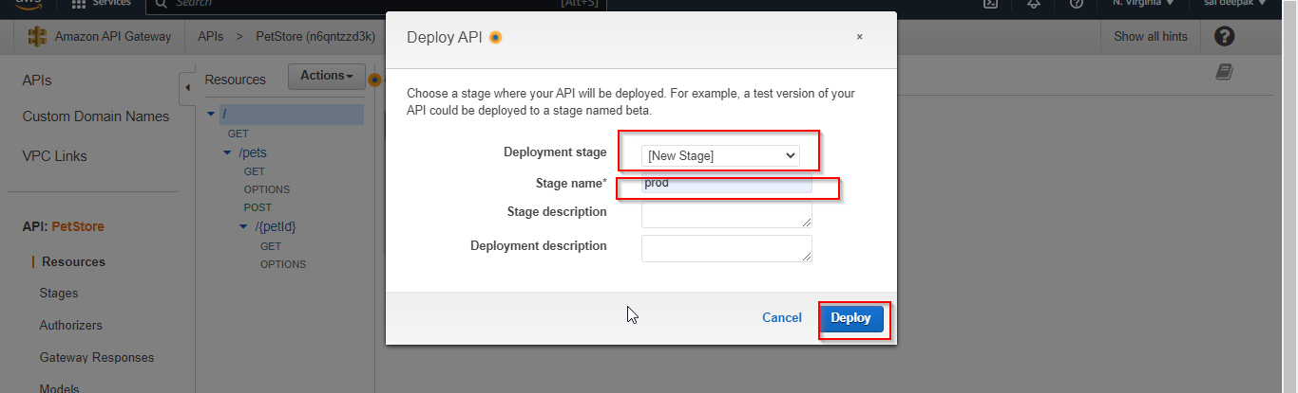

🡺 After creating the **Prod , we need to select the Swagger and export the Swagger output JSON**

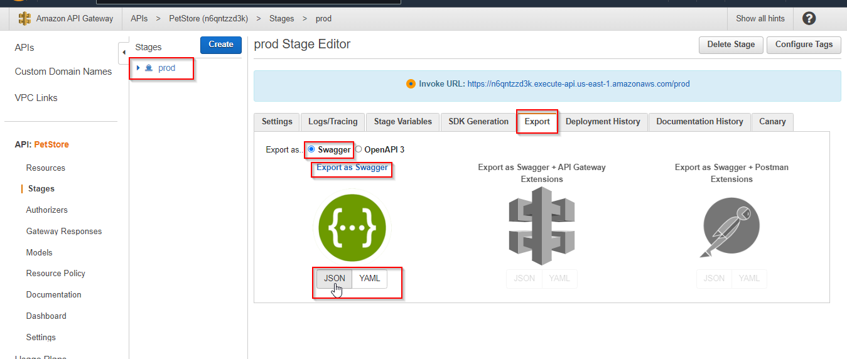

Now we need to export the JSON file in BOTO3 code.

**BOTO3 Code :**

import boto3

import json

client = boto3.client('apigateway')

response = client.get_export(

restApiId='4kip71jpv3',

stageName='prod',

exportType='Swagger',

parameters={

'extension': 'apigateway'

},

accepts='application/json'

)

my_json = json.loads(response['body'].read())

with open('result.json', 'w') as fp:

json.dump(my_json, fp)